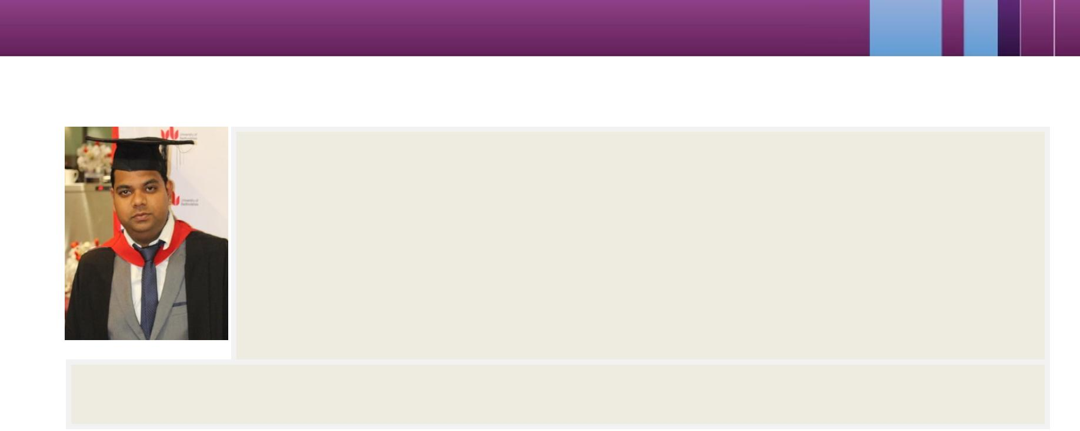

Name: Yogendra Ga jbhiye

Date of Birth: 21-02 -1989 Passport Number: H5310182

Contact No: +91- 77 71867009

Email ID: Yogendra.gajbhiye@gmail.com Specialization: MBA (University Of Bedfordshire, U.K)

Objective: To enha nce my skills by working in an Employee Oriented Organization with professional enviro nment and contribute to the organization with best of my ability and utilize the strong foundation o f knowledge acquired so far.

Core Strengths: Employee relationship, Human Resource Management, Space Selling, Lead Generation, Business

Development, Client Acquisition, Client S ervicing, Client Retention, Team Leading, Mentorsh ip, Relationship Building,

Work Experience

 | Duration | Co mpany |  | Designation | City
 | 1 Years | Topps Tiles London, (U.K) |  | Human Resource Manager | London
 | 1 Years | Lebara Mobile (U.K) |  | Sales Manager | London
 |  |  | Live Project
 | Duration | Co mpany |  | Designation | City
 | 6 Months | Amazone.co.uk |  | Sales Intern | Luton, (U.K)
 | 2 Months | Sainsbury’s PLC |  | Marketing Trainee | London


Topps Tiles London, (U.K): Feb 2013 -Present
Job Profile:

Was responsible for listening to the employees issue and try to resolve them. S hould be able to acquire large number of accounts in terms of quantity.

To give regular feedback on emplo yee development, training and other factors influencing management. Interact regularly with the employees to ensure a healthy environment in a company.

To managing their holidays and to make sure that they are getting proper ben efits of the company.

Lebara Mobiles (London, U.K): Feb 2012
Job Profile:

To promote and sell companies scheme to the customers.

Generating potential leads in the c orporate and telecommunication sector on a local and regional level. Informing and educating about th e new plans to my team.

Identifying and developing a sustained network of channel partners for increased growth and market reach.

Yogendra Gajbhiye Email: yog endra.gajbhiye@gmail.com Ph: +91-7771867009


Amazon (Luton, U.K):
Job Profile: All of my work experiences have involved working within a team-based cul ture. This involves planning, organization, coordination an d commitments e.g.: in amazon daily target we re made and had an effective communication among all staff members.

Sainsbury’s PLC:

Job Profile: Marketing strategy of Sainsbur y’s.


EXTRACURRICULAR ACHIEVEMENTS:

Developed a Marketing Comm unication report and presentation on a new Travel agency as my Project Dissertation.

Developed a fully working webs ite for an estate agency.

Participated in Pune “International marathon” 2011

Academic Qualification

 | Qualification | College/Board | University/Board | D uration | City
 | MBA | University Of Bedfords hire (U.K) | U.BEDS | 2012-13 | London
 | Software Egg | Aptech Computer Education | ACCP | 2011-12 | Bhilai
 | B.Com | St. Thomas College | PRSU University | 2007-10 | Bhilai
 | HSC | N.E.M.S | CBSE | 2006-07 | Durg
 | SSC | N.E.M.S | CBSE | 2004-05 | Durg



Desk Projects:

A project on National Economic Pl anning on the topic “Inclusive growth of India is more of populist agenda”

Transform previous disorganiz ed HR department in to well functioned and cost effective employee survey data.

Role of IT in Management.

Implemented, integrated and m aximized usage of new HRIS employees.

Brought project in 16% under budget and dramatically improved efficiency of HR functions.

Other Interest:

Travelling and exploring new place s

Going adventurous as it gives me a bility to survive in different conditions. I like to socialize with people

Surfing on internet which keeps me touch with general awareness and updates me time to time.

Yogendra Gajbhiye Email: yog endra.gajbhiye@gmail.com Ph: +91-7771867009

